RF TRANSMITTER & RECEIVER

RF Transmitter & Receiver Architectures:
Basic Building Blocks

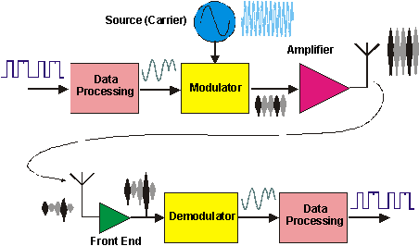

Frequency Source (Carrier)

In order to make the information signal (e.g. data) pass through the air, it must be modulated on to a carrier signal whose frequency is well suited to the propagation environment, conforms to the licensed operating bands, and is sufficiently stable to allow detection by a tuned receiver in the presence of interference.
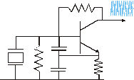

Modulation
The method of imposing the information signal onto the carrier signal is termed modulation and must be accomplished cost effectively and accurately for maximum range and minimum interference.

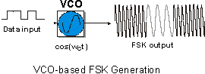
Amplification

The amplifier is a key part of the transceiver, and must be efficient (dc power in to RF power out), low cost, non-polluting, and possibly linear. Output power is dictated by regulation, range requirement, battery life, cost and linearity considerations.

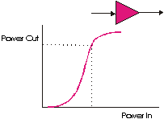

Antenna
The antenna is often the most poorly engineered part of a radio system. Good design will ensure maximum range, high amplifier efficiency (good matching), good selectivity, minimal pollution, good interference rejection, good sensitivity, reduced design headaches.

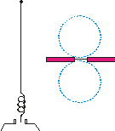

Reception
Key to the sensitivity, dynamic range and strong signal handling properties of the radio is the receiver ‘front end’. The main task is to boost weak wanted signals, often in the presence of strong unwanted signals whilst introducing minimal noise and distortion. In many cases, some selective filtering is required to assist this task.

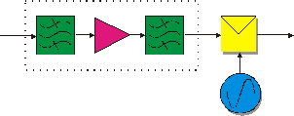
Demodulation

The process of removing the information signal from the carrier is termed demodulation. The challenge is to design a circuit (or algorithm) that will achieve this task optimally in the presence of noise, interference and varying signal strength, frequency and phase, whilst being compact, power efficient and cheap.
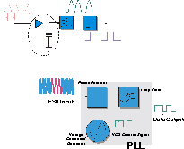

Data Processing
Pre and post processing of the information signal is often an after thought for low power radio applications, usually implying some form of microprocessor or DSP engine with the presumed complexity, cost, power consumption and size penalties. The benefits of matched filtering, error detection and correction (coding), channel equalization, etc, are however significant in terms of range, robust transmission, power conservation and data rate optimization.

